**PIZZA SALES ANALYSIS**

**KPI’S**

1. **Total revenue**

select sum(total_price) as Total_Revenue from pizza;

https://lh6.googleusercontent.com/xRKbUL8tJJHZsG7wX5WQCHR3aNEYnOcotblLBV1wXsvwGmoQ4oqXY-WB3SUTZ-Z-XtJ5A_xlwnDBycIjSWwoQ3ycYsUSXy6GoqLQ4jmEKe_qAeg3bm3oFu3XKJjhxmiSEyybgfwaYVXcVeADyWyn3CU

1. **Total pizza sold**

select sum(quantity) as total_pizza_sold from pizza;

https://lh5.googleusercontent.com/Z4G5J6q_Sk8h3Sf6nuM_nA8H8m-x9-OCgaDU4HkwOiOyD2J0rJsWSB1zfE-peRF0P5b2v_2FPvo4reVR_H6QCatZUOkqmP3fnRdTpn0r42Asa3mcmDoJm3W-zPyNfooSP0jNBMDtmweT6EuJWCY3oAU

1. **Total orders**

select COUNT( distinct order_id) as total_orders from pizza;

https://lh4.googleusercontent.com/K1CiaRw6hxdC7pVCEY-MRyrrE4jdevF68e8hfFT_6Yg7CEUtc8gHFw0aUKfJoGyrkWGmUkkhMkv_Z2FojAjhT3PCXTbpQq2ELHWTJHKKJO43oydeOJKCcMG_zjnQdGqawbwP4B19XpYjo2hnjW4VC-U

1. **Avg order value**

select sum(total_price) / COUNT( distinct order_id) as total_orders from pizza;

https://lh3.googleusercontent.com/H4SOrGOpm5cKetRpJl-iYB42JwRkO4TyZeQurtdOQV7ifp15l_sb_-Vl2AIxBOZiza5vRgejkmj78cU7iJbswBg615z9i9oo3Pa9W9o9IxbojEs_i-VHHmWKl0vut8odl1ayPn4P9m_4tSByfg1gXNs

1. **Average pizza per order**

select CAST(sum(quantity) AS DECIMAL (10,2)) / COUNT(distinct order_id) AS AVG_PIZZA_PER_ORDER  from pizza;

https://lh5.googleusercontent.com/8_-ZJEI08QkpN8f4zVFeK341kK4pEocBajE5TsiamG_dH_Vz1D4HGDIOS5WCg7nLxpCuebMbxLhnywid77M_4_V1-mRrApkVQRn9EePn8ujt_32Dnk8Gi_fVGmN4E9yPjfb77vn1HAIOJ0tLTY9eMPQ

1. **Percentage and total sales by pizza category**

select pizza_category,sum(total_price) as total_sales, sum(total_price) * 100/ (select sum(total_price) from pizza)  as Total_sales_percentage from pizza

group by pizza_category

order by  pizza_category;

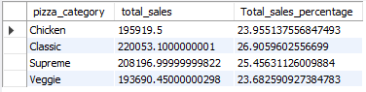

1. **Top 5 pizza according to revenue**

select pizza_name, sum(total_price) as total_revenue from pizza

group by pizza_name

order by sum(total_price) desc

limit 5;

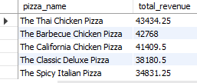

1. **Bottom 5 pizza according to revenue**

select pizza_name, sum(total_price) as total_revenue from pizza

group by pizza_name

order by sum(total_price)

limit 5;

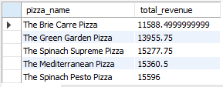

1. **Top 5 pizza according to quantity**

select pizza_name, sum(quantity) as Quantity from pizza

group by pizza_name

order by  sum(quantity) desc

limit 5;

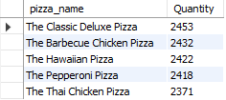

1. **Bottom 5 pizza according to quantity**

select pizza_name, sum(quantity) as Quantity from pizza

group by pizza_name

order by  sum(quantity)

limit 5;

